**World Quant University**

**Professor: Harry Wang**

**Algorithms II**

Nikolas Lippmann Pareschi - [nikolaslippmann@gmail.com](mailto:nikolaslippmann@gmail.com)

**Assignment 7: Branch and Bound**

### Problem 1:  Cutting plane method

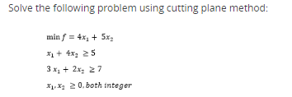

In the definition of our variables we define that the constraints should be at least equal to zero. Cutting plane methods work by solving a non-integer linear program, the linear relaxation of the given integer program. We so solve the continuous problem:

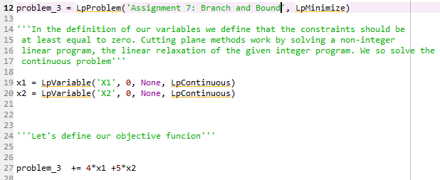

Let’s define our constraints:

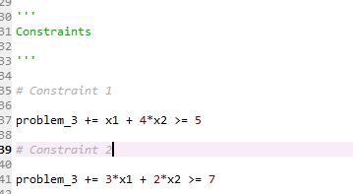

Solving the Problem:

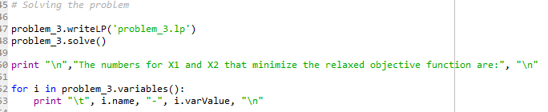

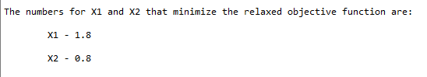

We have from our material that if the objective function coefficients are integers, then for minimization, the optimal objective for (IP) is greater than or equal to the “round up” of the optimal objective for (LR).

As this is our case the optimal objective may be be X1 = 2 and X2 = 1 . These numbers obey the constraints and as the objective function is a sum, any other numbers for X1 and X2 will imply a higher f(x) by induction. It follows so that X1 and X2 minimizes the objective.

Let’s check our results:

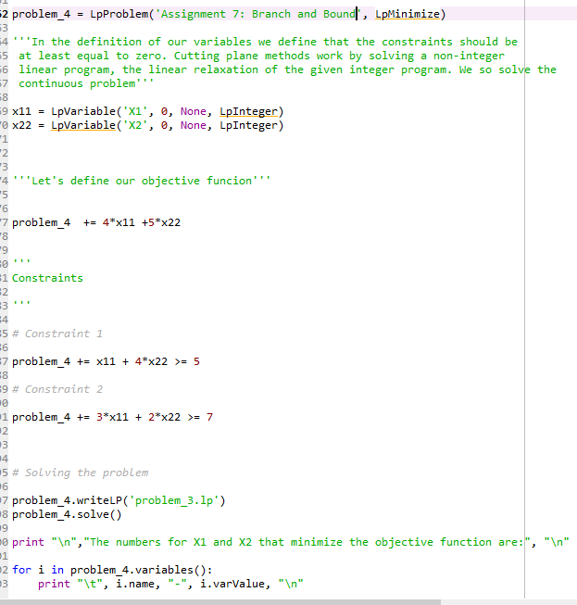

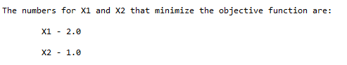

Regarding financial applications and alpha generation, linear problems can solve for example the necessity of hedge funds to maximize the capital invested without buying fractional lots, which have less liquidity. Also, we see some academic papers that used linear programming to alpha generation [3]:

***Abstract***

*This is a classic study, by the “Old Masters”, of the method-centered approach to management problems. It demonstrates once again the extraordinary power of the linear-programming framework, in dealing with complex business-decision problems. Students of the capital-budgeting process will find it filled with insights, and highly suggestive. It may eventually become the established basis for a revised conception of the interaction between financial planning and the economic analysis of engineering projects.*

[1] <http://mathworld.wolfram.com/SimplexMethod.html>

[2] <https://en.wikipedia.org/wiki/Simplex_algorithm>

[3] <https://www.tandfonline.com/doi/abs/10.1080/001379X6008546907?journalCode=utee20>